Activity 2.2: Flower design algorithm
Create an algorithm that could be used to program a computer to draw the following flower.

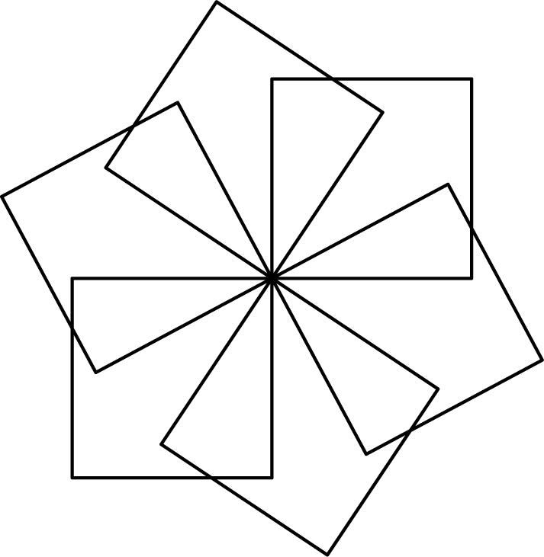

This abstracted flower design is made up of squares. The four internal angles of a square are all 90 degrees.

